**Enrollment Guide of Chifeng University**

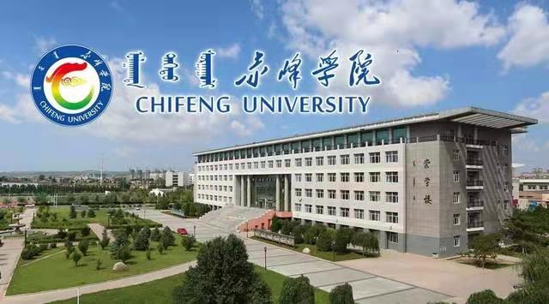

1. **Tour of Chingfeng City**

Chifeng City, named by the Red Mountain in its northeast corner, is located in Inner Mongolia Autonomous Region. Chifeng boasts a long history and a profound cultural background. 10,000 years ago, there were humans multiplied and lived. 8000 years ago, the ancient Xinglongwa people set up "the first Chinese village" and the first seed of human civilization was sowed at here. 5000 years ago, Hongshan culture originated from here.

Chifeng is well-known for its beautiful scenery and unique human landscape. In recent years, Chifeng City stepped up ecological construction and protection, awarded as the national standard-bearer of advanced anti-desertification. Meanwhile; the ecological situation has been improved markedly. In this land, grasslands, forests, mountains, deserts, hot springs, lakes, stone forest can be found.

Chifeng possesses convenient transportation and obvious advantages. It is a transport hub，connecting Chifeng, the eastern and western area of Inner Mongolia, north-east part of China and the north part of China. There is only 315 km from Beijing to Chifeng. So it is nicknamed as the "back garden of Beijing."

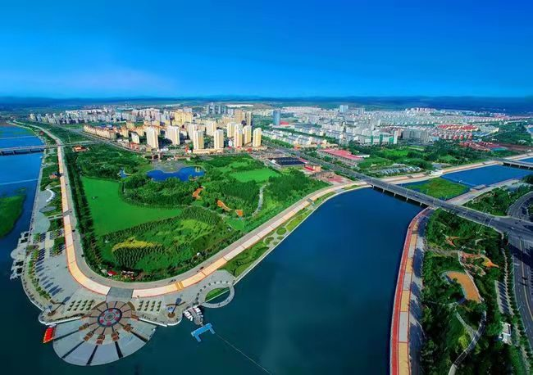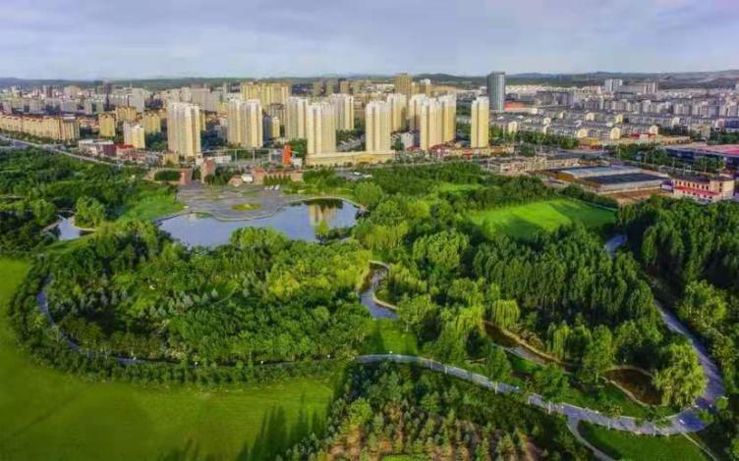

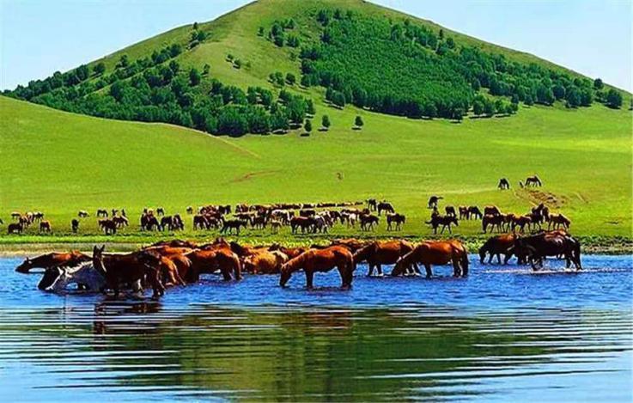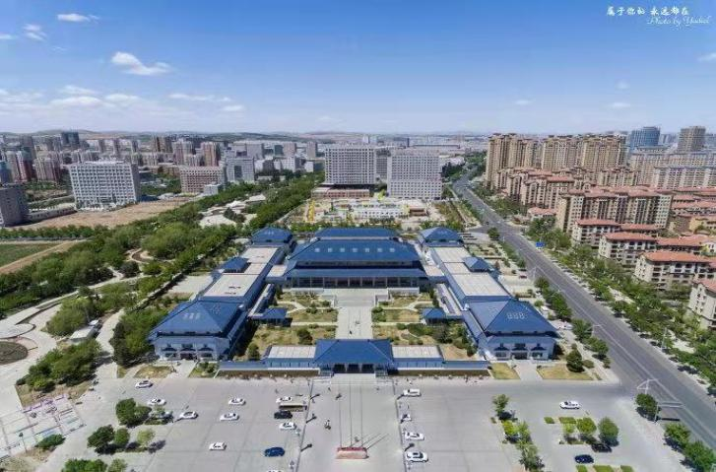

## Airlines and Destinations

|  |  |
| --- | --- |
| **Airlines** | **Destinations** |
| [Air China](http://en.wikipedia.org/wiki/Air_China" \o "Air China) | [Beijing-Capital](http://en.wikipedia.org/wiki/Beijing_Capital_International_Airport" \o "Beijing Capital International Airport) Airport, Hohhot |
| [Huaxia Airlines](http://en.wikipedia.org/wiki/Beijing_Capital_Airlines" \o "Beijing Capital Airlines) | [Hohhot](http://en.wikipedia.org/wiki/Hohhot_Baita_International_Airport" \o "Hohhot Baita International Airport),Baotou, Dalian, Erlianhot |
| [China Eastern Airlines](http://en.wikipedia.org/wiki/China_Eastern_Airlines" \o "China Eastern Airlines) | [Shanghai-Pudong](http://en.wikipedia.org/wiki/Shanghai_Pudong_International_Airport" \o "Shanghai Pudong International Airport) Airport, [Tianjin](http://en.wikipedia.org/wiki/Tianjin_Binhai_International_Airport" \o "Tianjin Binhai International Airport) |
| [China United Airlines](http://en.wikipedia.org/wiki/China_United_Airlines" \o "China United Airlines) | Beijing Daxing Airport |
| Jinpeng Airlines | Hohhot, Zhengzhou |
| [Zhejiang Loong Airlines](http://en.wikipedia.org/wiki/Sichuan_Airlines" \o "Sichuan Airlines) | [Hohhot](http://en.wikipedia.org/wiki/Hohhot_Baita_International_Airport" \o "Hohhot Baita International Airport), Xi’an, Hangzhou, Haerbin |
| [Tianjin Airlines](http://en.wikipedia.org/wiki/Tianjin_Airlines" \o "Tianjin Airlines) | [Hohhot](http://en.wikipedia.org/wiki/Hohhot_Baita_International_Airport" \o "Hohhot Baita International Airport), Hulunbuir, Tianjin |
| Shanghai Jixiang Airlines | Qingdao, Shanghai-Pudong Airport |

|  |  |  |  |  |  |  |  |  |  |  |  |  |  |
| --- | --- | --- | --- | --- | --- | --- | --- | --- | --- | --- | --- | --- | --- |
| **Month** | **Jan** | **Feb** | **Mar** | **Apr** | **May** | **Jun** | **Jul** | **Aug** | **Sep** | **Oct** | **Nov** | **Dec** | **Year** |
| **Average high °C (°F)** | −3.4 (25.9) | 0.2 (32.4) | 7.1 (44.8) | 16.7 (62.1) | 23.4 (74.1) | 27.5 (81.5) | 29.4 (84.9) | 27.9 (82.2) | 23.0 (73.4) | 15.6 (60.1) | 5.8 (42.4) | −1.1 (30) | 14.3 (57.7) |
| **Average low °C (°F)** | −16.3 (2.7) | −13.4 (7.9) | −6.3 (20.7) | 2.7 (36.9) | 9.9 (49.8) | 15.3 (59.5) | 18.5 (65.3) | 16.5 (61.7) | 9.8 (49.6) | 2.1 (35.8) | −6.5 (20.3) | −13.2 (8.2) | 1.6 (34.9) |

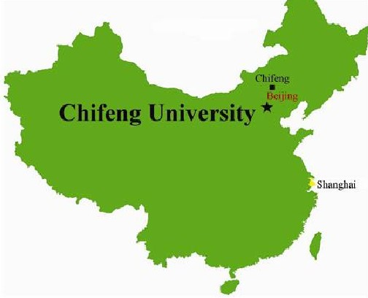

**II. Introduction of Chifeng University**

Approved by the China Ministry of Education, Chifeng University was founded as full time and comprehensive university by the combination of five Institutes: Chifeng Teachers College (1957), Chifeng Institute of Education (1979), The Radio and Television University of Inner Mongolia (1982), Zhaowuda Union Health College (1958), Chifeng Art Tourism College. It is located in Chifeng City, the birthplace of the world-famous Hong Shan Cultures. The city boasts profound cultures with time honored history, distinctive scenic spots and rich literal human resources, which is the famous tourism city of China.

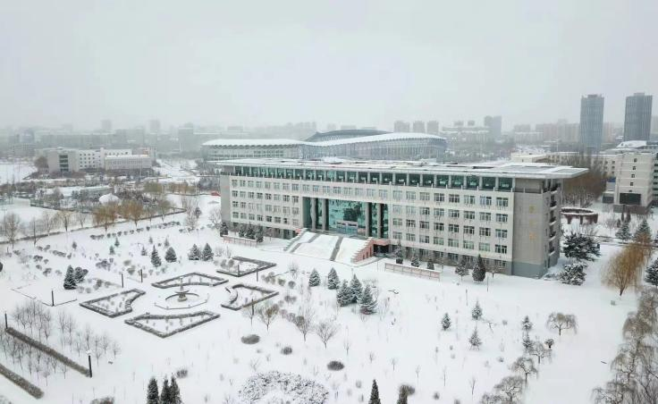 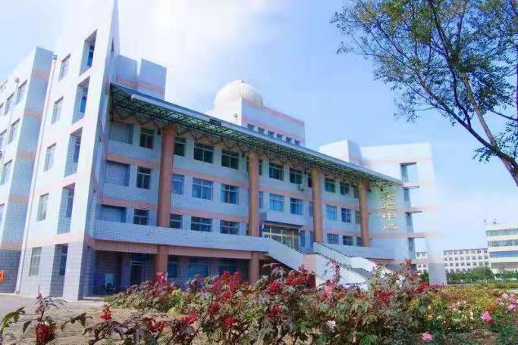

The university has established a comprehensive discipline system with 25 colleges. Its specialties cover 11 disciplines including literature, history, laws, education, science, engineering, medicine, management and liberal arts. It offers 58 undergraduate programs and 9 post-graduate programs.

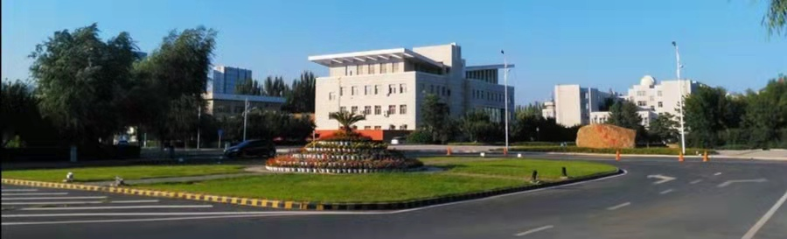

The University occupies a total area of 1800 mu or 120 hectares with 211 thousands square meters building area. The total value of the capital asserts is 399 million Yuan. In the University, many modern teaching and research facilities have been set up, such as the laboratories of various specialties, the professional practice training rooms, the computer center, the digital campus network, the gymnasium and the multimedia classrooms. The library of the Chifeng University has a collection of 841000 books, 179000 e-books and 7 comprehensive full-text databases.

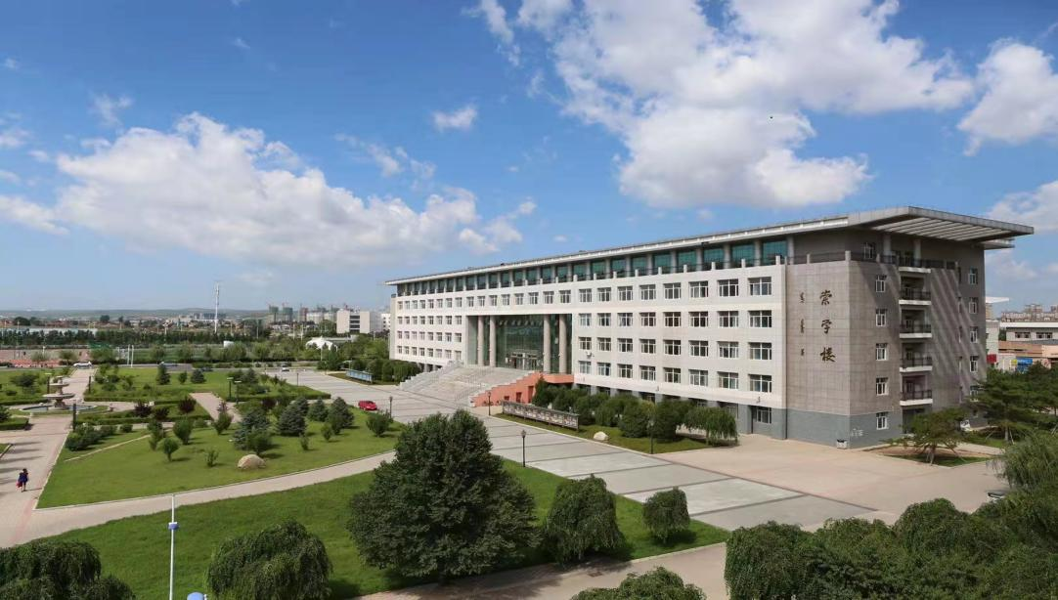

The university has strong faculty with 1017 full-time teachers, including 173 professors and 619 associate professors. Among them, 873 teachers have doctor or master degrees. There are more than 13000 full time students and more than

8000 students in adult education.

The teaching principle of the university is to base itself upon the local area, face the whole region, cover the vicinity, to train the application-type and skill-type high-level special personnel for the local economy construction and the social development. The object is to build the university into an all-around university incorporating the common higher education, the adult education and higher vocational education. Upholding its spirit of being virtue respected, dedicated, realistic and innovative, the university takes moral education as its foundation, improvement of education quality as its main task. It initiatively adapts to the internationalized development trend of higher education and insists in running the school in an open manner, namely, open to international students, open to the outside world with open minded. The university continues to deepen the teaching reform and innovate the training model. It focuses on producing students with healthy personality, innovative spirit and strong practical capacity in order to improve the quality of personal training. The university strives to build it as a comprehensive and teaching-intensive one with strong national and local characteristics.

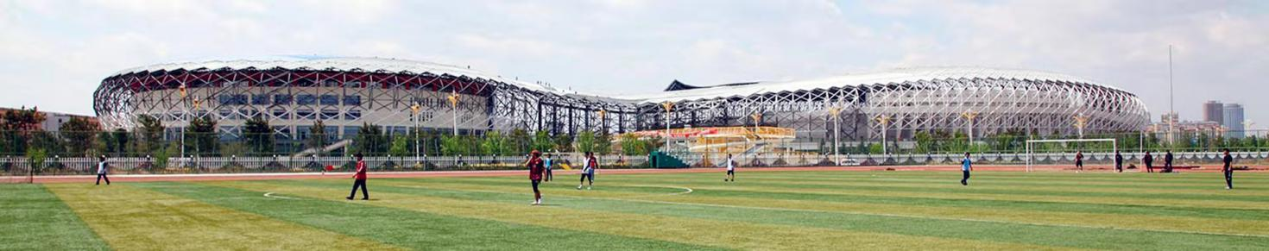

**Clinical Medical School of Chifeng University**

The Zhaowuda Union Health School founded in 1958 is the predecessor of the Chifeng University Clinical Medical School (CUCMS). July 1962 it changed its name to Inner Mongolia Chifeng Health School. April 2003 this school merged with Chifeng University and become Chifeng University Medical Branch. In December 2004 it’s was renamed Chifeng University Medical College (CUMC). It is recognized by W.H.O, IMED and approved by PMDC. Clinical Medical School has a staff of 160 professional and technical personnel including 130 full-time teachers among whom 27 professors, 34 associate professors, 3 holding doctor degree, 29 master degree. At present Clinical Medical School has 9000 students including more than 145 International students from Pakistan, Zambia and Namibia. Clinical Medical School has 2 Affiliated Hospitals, 6 Teaching Hospitals, and 8 Internship Hospitals.

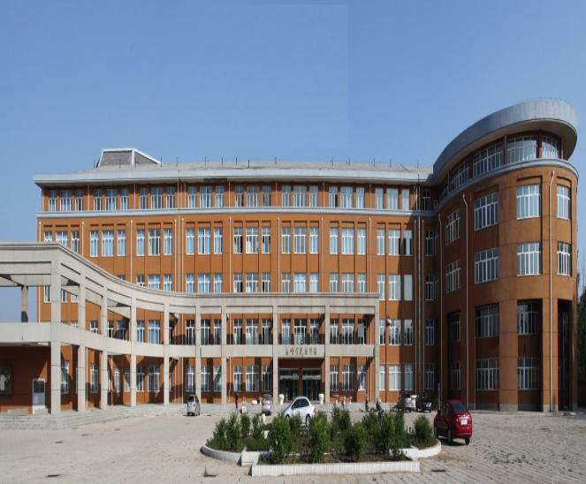

|  |  |
| --- | --- |
| **Program Name** | **Remarks** |
| Clinical Medicine (M.B.B.S) | Provincial Key Program |
| Dental Medicine (B.D.S) | Provincial Key Program |
| Medical Laboratory | University Key Program |
| Nursing | University Key Program |

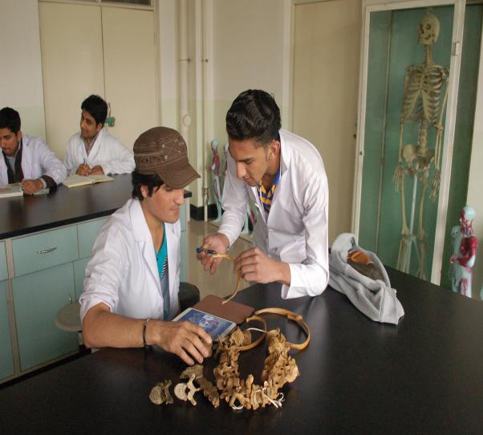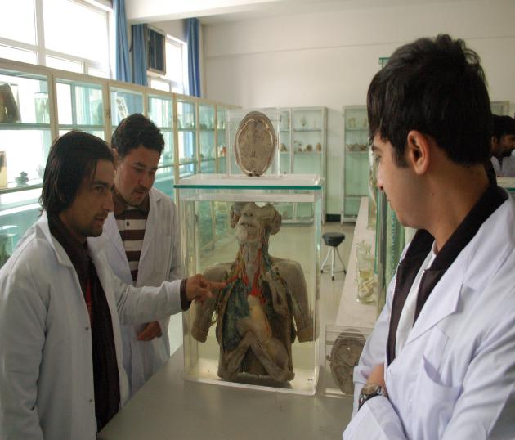

**Affiliated Hospitals of Chifeng University**

**The First Affiliated Hospital**

The First Affiliated Hospital is an III-A hospital, established in 1980, having 3200 beds with first class facilities to conduct cardiac surgery, brain surgery, the general surgery, orthopedics and other difficult surgery in the autonomous region.

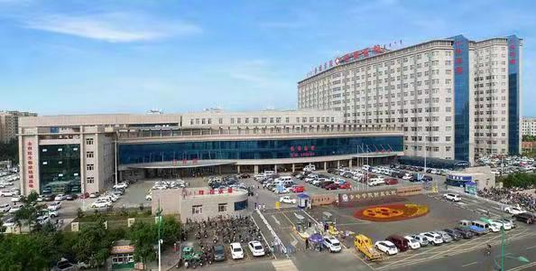

**The Second Affiliated Hospital**

The Second Affiliated Hospital is an hospital having 400 beds, consists of 25 clinical and medical department with 113 professional and technical personnel having facilities of CT, X-ray machines, C-arm and other large equipment.

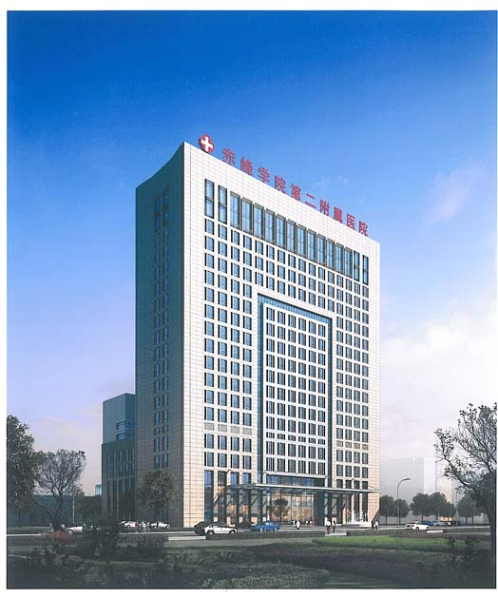

**Clinical Medicine / M.B.B.S Program of Chifeng University**

In 2012, Chifeng University started M.B.B.S program for international students. Three Batches of International students had graduated.

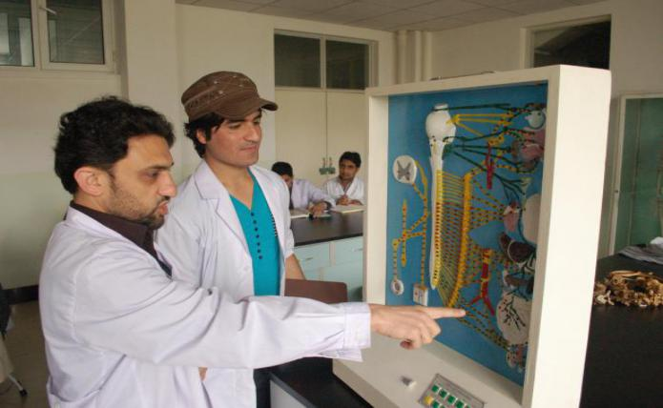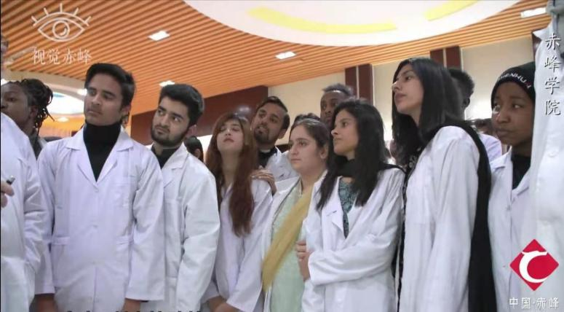

The MBBS (Bachelor of Medicine & Bachelor of Surgery) program of Chifeng University is a medical education program specifically designed for international students who wish to pursue a medical bachelor degree in China. The composition of M.B.B.S. program is fully under the guideline of ‘Provisional Regulations on Quality Control Standards of Undergraduate Medical Education for International Students and Global Minimum Essential Requirements in Medical Education’. The overall goal is to develop extensive medical knowledge and lay a solid foundation for their further studies in any medical branch for medical graduates. Special requirements of other countries where most students originally come from are also taken into account. The M.B.B.S. curriculum is organized in a disciplinary setting based on a school’s existing undergraduate medical education program and composed of two stages, pre-clinic and clinic stage.

**Duration:**

6 Years (5 Years Study+ 1 Year Internship)

**Courses**

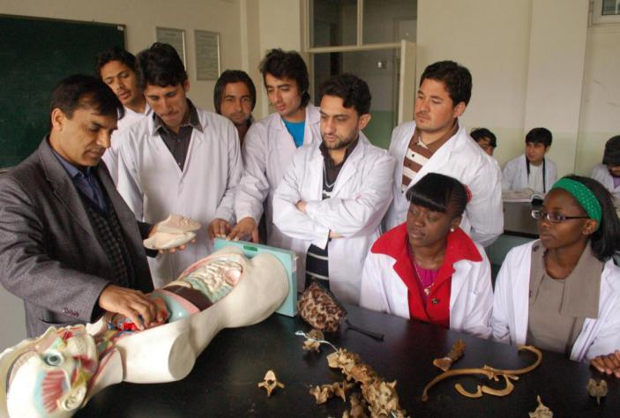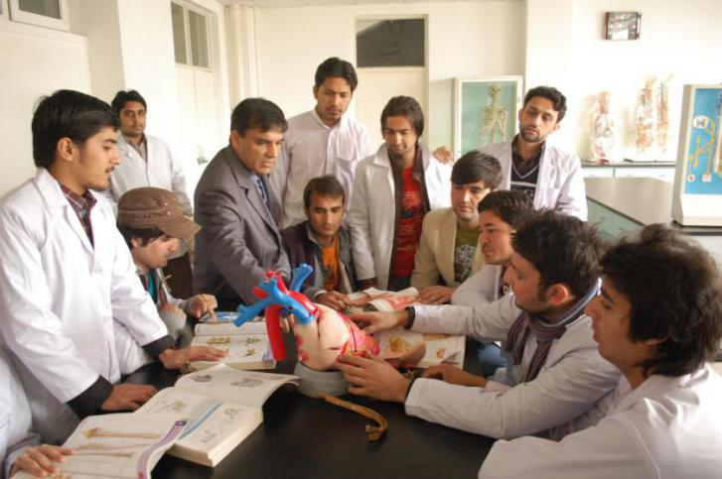Anatomy, histology, embryology, physiology, biochemistry, pathology, microbiology, pharmacology, forensic medicine, diagnostics, preventive medicine, internal medicine, surgery, obstetrics & gynecology, pediatrics, psychology, E.N.T, dentistry, psychiatry, anesthesia, ophthalmology, dermatology, emergency medicine.

**Classrooms**

University has modern educational facilities which include the Computer Center, Audio-visual Educational Information Center, Network Teaching Laboratories, Multi-media Micro-teaching Laboratories, Multi-media Classrooms, Music Hall, Artists Gallery, campus-net, cable TV and broadcasting systems. All highly qualified teachers are teaching M.B.B.S course, so as to make the teaching-learning experience a live procedure. This enhances the content understanding and practical capability of a student. The teachers are committed to transform every student into a competent doctor with individual care.

**Laboratories**

Medical College has five laboratories: Medicine Lab, Dentistry Lab, Nursing Lab, Pharmacy Lab and Medical Tests Lab and two research centers which are Basic Medical Research Center and Research Center of Molecular Medicine.

**Library**

The library of the Chifeng University has a collection of more than 900,000 books, 400,000 e-books and 14686 electronic periodicals.

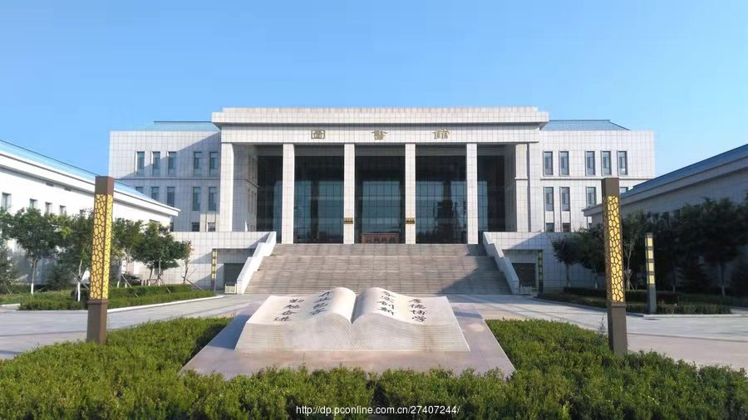

**Hostel**

There is separate hostel for boys and girls. Well-appointed hostels with fully furnished Air-conditioned rooms made for international students. Rooms are furnished with beds, study tables, internet access, and air conditioning. The hostels are given good protection by security agencies and police booths on campus.

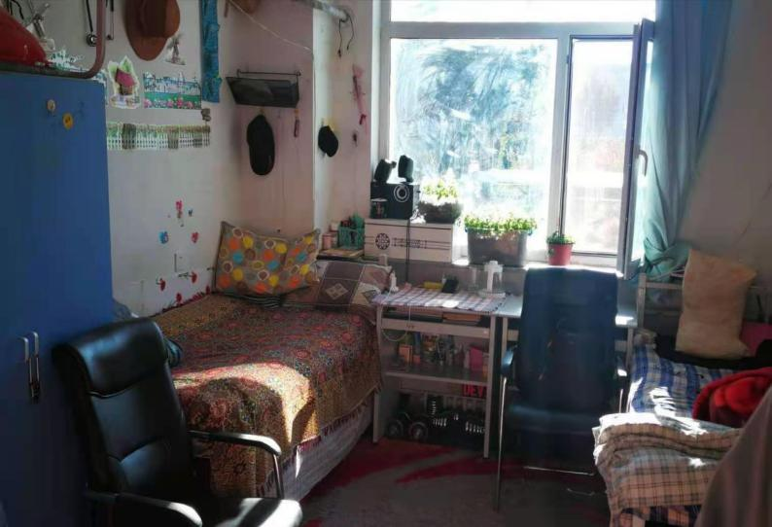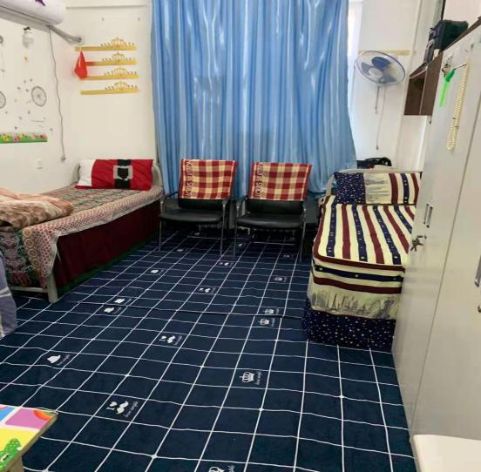

**Cafeterias**

There are cafeterias on the campus, with many different styles of food. Halal Food is available. For international students, breakfast, lunch, supper and all kinds of snacks are available at very reasonable cost.

**Sports**

The University has a standard 400M synthetic-track sports field and also has various kinds of sports venues and facilities, including stadiums, venues for track and field events, swimming pools and etc. A gymnasium provides students with an opportunity to do in-door physical exercises.

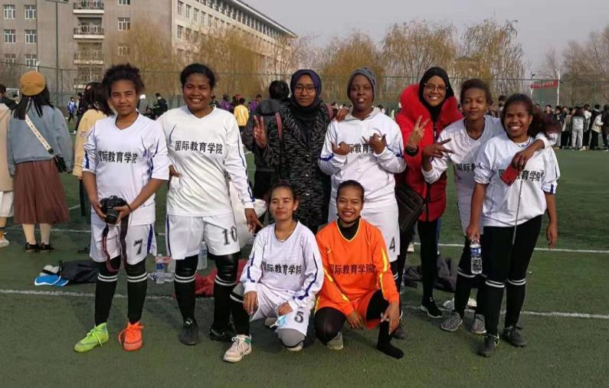 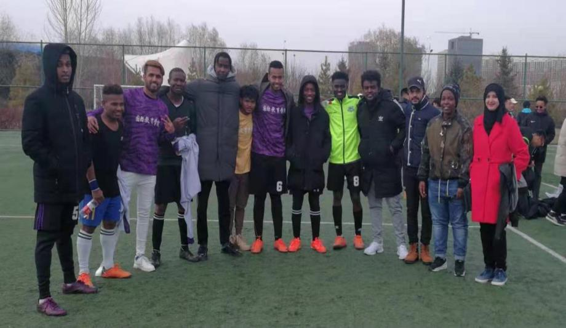

**Facilities**

On campus there is a campus infirmary, canteens, bank ATMs, supermarkets, laundries, book stores, etc.

There are some convenient living facilities such as large-scale public hospital, bank, post office, supermarket, cinema, gymnasium, parks and so on around the campus.

**III. Why Chifeng University**

* Government University
* Founded in 1958
* Near Beijing
* Recognized by WHO, IMED
* Students are eligible to appear in USMLE, PLAB, AMC, MCI, PMC, ECFMG
* 25 Schools with 58 undergraduate programs
* University has strong faculty with 1017 full-time teachers
* More than 13,243 Chinese and 145 International Students
* Teaching MBBS program to International students since 2012
* Teaching MBBS program according to International standard
* Three Batches of MBBS International students already graduated
* 2 Affiliated Hospitals, 6 Teaching Hospitals, and 8 Internship Hospitals
* International cooperating with universities of United States, United Kingdom, Germany, France, Canada, Australia, Japan, South Korea, Mongolia

**IV. Eligibility Criteria**

* Filled application form
* Matric / O Level Certificate
* Fsc / A Level Certificate
* Passport Copy
* Physical Examination Certificate
* Police Character Certificate
* Passport Size Picture
* Age limit 18-25 Years

**Campus of Chifeng University**

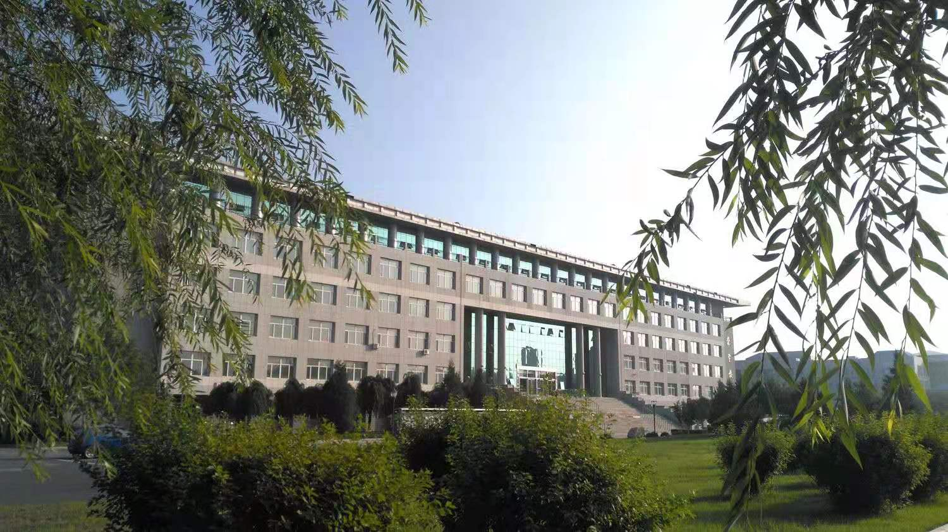

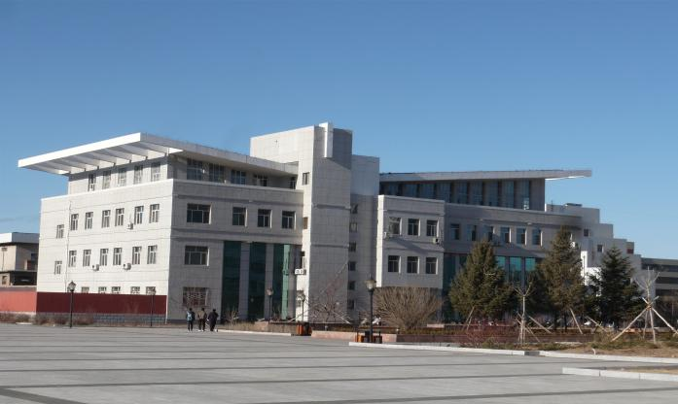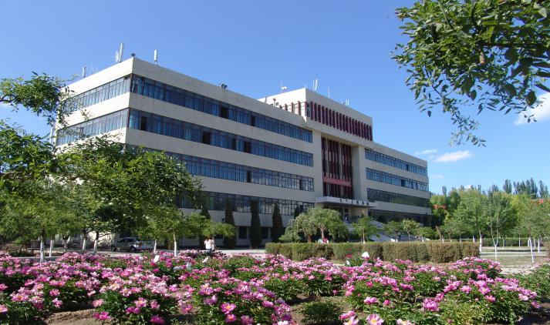 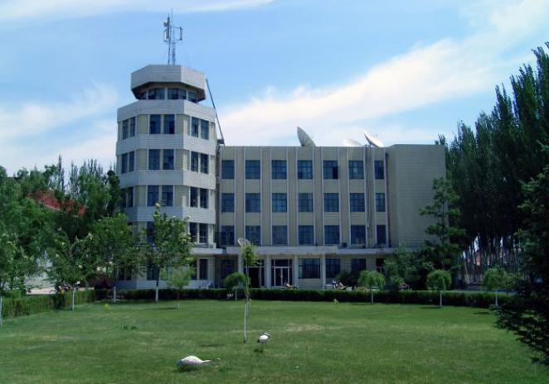 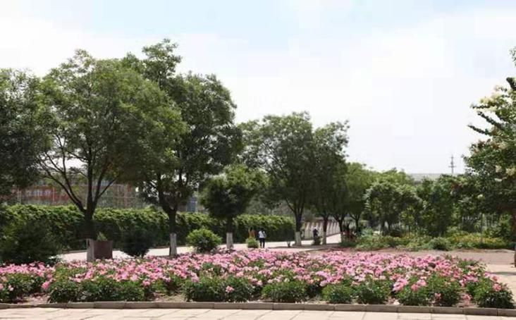

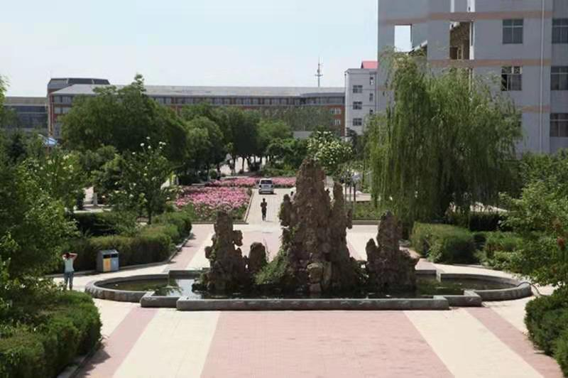

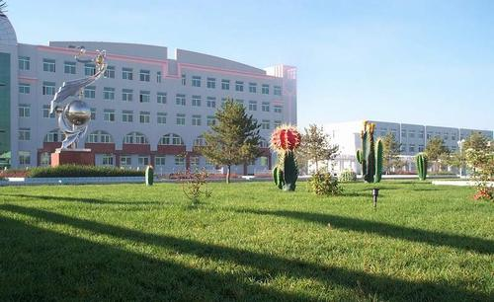

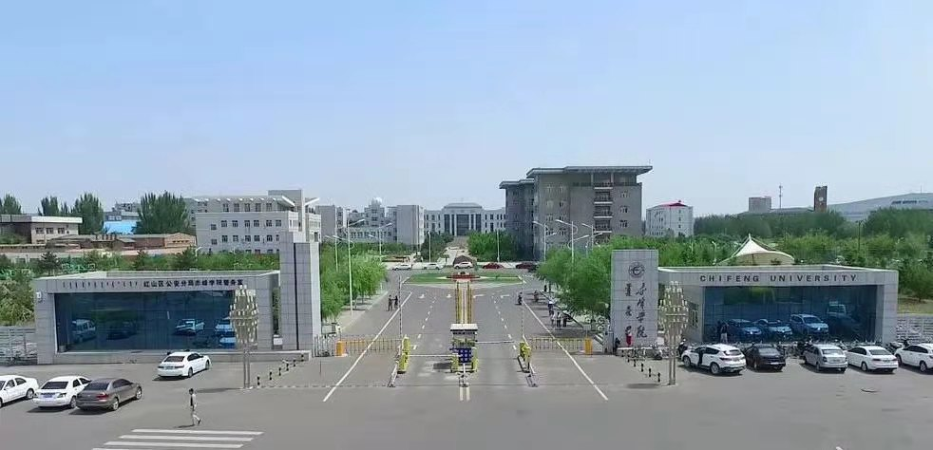

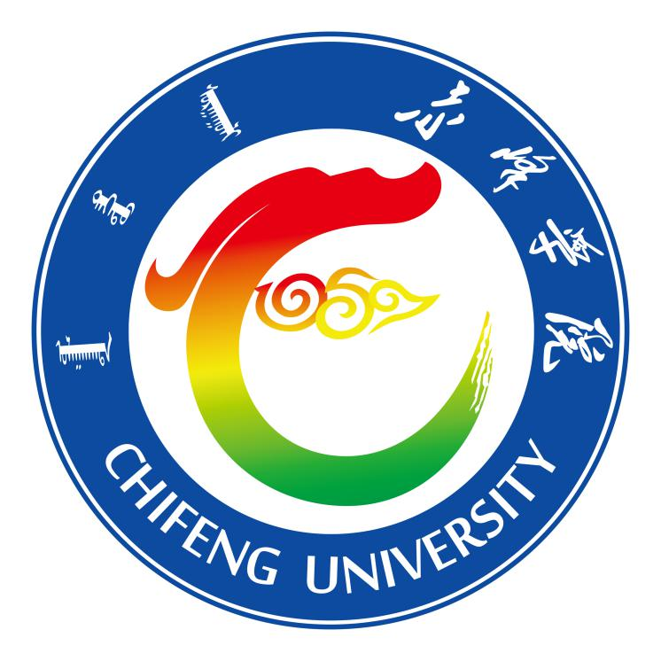**Contact Us**

**Telephone**

Tel: 0086-476- 8300526  
**Fax**

0086-476-8300523

**Email**

cies@cfxy.edu.cn

**Website**

<http://www.cfxy.cn>

**Address**

Foreign Affairs Office, Chifeng University  
Ying Bin Road, Chifeng, Inner Mongolia

the People’s Republic of China, 024000

